Volume 1 – Technical & Management Proposal

**Cover Sheet**

|  |  |
| --- | --- |
| (1) BAA Number | **IARPA-BAA-20-01** |
| (2) Topic and Area of Interest – (Reference BAA Section 2.2) | BAA section 2.2.B |
| (3) Lead Organization Submitting Proposal | North Carolina Central University |
| (4) Type of Business, Selected Among the Following Categories: “Large Business”, “Small Disadvantaged Business”, “Other Small Business”, “HBCU”, “MI”, “Other Educational”, or “Other Nonprofit” | “HBCU” |
| (5) Offeror’s Reference Number (if any) |  |
| (6) Other Team Members (if applicable) and Type of Business for Each | Dr. Zachary M Boyd “Other Educational”  Dr. Mahour Parast “Other Educational” |
| (7) Proposal Title | Multi-Tier and Multi-Layer Analysis of Global Supply Chain Network: Mapping, Risk Identification, and Scenario Planning for Security & Rupture |
| (8) Technical Point of Contact to Include: Title, First Name, Last Name, Street Address, City, State, Zip Code, Telephone, Fax (if available), Electronic Mail (if available) | **Technical**: Dr. Kayvan Miri Lavassani, (919) 530-5028, [klavassa@nccu.edu](mailto:klavassa@nccu.edu). |
| (9) Administrative Point of Contact to Include: Title, First Name, Last Name, Street Address, City, State, Zip Code, Telephone, Fax (if available), Electronic Mail (if available) | **Administrative**: Kendra C Cardwell, Assistant Director, Pre Award, Office of Sponsored Research: (919) 530-7756, [kcardwell@nccu.edu](mailto:kcardwell@nccu.edu) . |
| (10) Volume 1 no more than the specified page limit | Yes |
| (11) Restrictions on Intellectual property rights details provided in Appendix A format? | Not applicable |
| (12) Research Data Management Plan included? **Not Applicable** | Not applicable |
| (13) OCI Notification | Not applicable |
| (13a) If No, is written OCI certification included (see Appendix A)? | Yes/No |
| (14) Are one or more U.S. Academic Institutions part of your team? | Yes |
| (14a) If Yes, are you including an Academic Institution Acknowledgment Statement with your proposal for each U.S. Academic Institution that is part of your team (see Appendix A)? | Yes/No |
| (15) Total Funds Requested from IARPA and the Amount of Cost Share (if any) | $ 694759 |
| (16) Date of Proposal Submission | 7/7/2020 |

**Transmittal letter**

**Introduction of team**

Drs. Kayvan M. Lavassani, Zachary M. Boyd, and Mahour Parast, researchers at North Carolina Central University (NCCU,) University of North Carolina at Chapel Hill (UNC-CH,) and Arizona State University (ASU,) respectively.

**PI: Kayvan Miri Lavassani, Ph.D.**

Dr. Kayvan Miri Lavassani is an Associate Professor at the NCCU School of Business. He is founding Editor of the Journal of Business Ecosystems (JBE) and Director of the Innovation & Entrepreneurship Business Ecosystem Lab (IEBE Lab), where he conducts research on developing global and regional business ecosystem networks using data mining and big data network analytics. Dr. Lavassani has previously developed large scale global networks of business ecosystems in the pharmaceutical, auto manufacturing, and telecommunications industries. Dr. Lavassani has published over 50 papers in journals and proceedings. He is a graduate of Carleton University.

**Zachary M. Boyd, Ph.D. (Subcontractor)**

Dr. Zachary M. Boyd is an expert on the mathematical and dynamical aspects of multidisciplinary network-based modeling. His contributions to the field of network science include applying advanced optimization tools to understand the statistics of community detection (Boyd, 2019) and developing one of the few codes capable of efficient semi-supervised clustering on networks with many millions of connections (Boyd, 2018.) Dr. Boyd supports numerous multidisciplinary teams in fields such as machine learning, neuroscience, explosives engineering, hyperspectral imaging, and genealogy.

**Mahour Parast, Ph.D. (subcontractor)**

Dr. Mahour Parast is an Eminent Scholar at the Del E. Webb School of Construction at the ASU School of Sustainable Engineering and the Built Environment. His current research is on supply chain risk and resilience management, technological innovation and entrepreneurship, and process and product innovation. He is also an invited member of the International Supply Chain Risk Management Network (ISCRiM.) He has been the principal investigator of several research and technology commercialization projects from the National Science Foundation (NSF,) US Department of Transportation (USDOT,) and VentureWell.

**BAA number**: IARPA-BAA-20-01.

**Offeror’s Program Name**: North Carolina Central University(?).

**Proposal validity period**: Phase 1: 9/1/2020 – 12/31/2020; Phase 2: 1/1/2021 – 8/31/ 2021.

**Type of contract vehicle being requested** (FFP = Firm Fixed Price)(?).

**Rationale**: North Carolina Central University is leading the project. The partners at UNC-CH and ASU are Subcontractors. Having our partners as Subcontractors is the most efficient and flexible way to have collaboration across the three universities.

**Non-negotiable Conditions:** ASU and UNC-CH partners must be considered Subcontractors.

**Administrative**: Kendra C Cardwell, Assistant Director, Pre Award, Office of Sponsored Research: (919) 530-7756, [kcardwell@nccu.edu](mailto:kcardwell@nccu.edu) .

**Technical**: Dr. Kayvan Miri Lavassani, (919) 530-5028, [klavassa@nccu.edu](mailto:klavassa@nccu.edu).

**Proposal**

**Proposal Overview**

**Project Title: Multi-Tier and Multi-Layer Analysis of Global Supply Chain Network: Mapping, Risk Identification, and Scenario Planning for Security & Rupture**

**Technical Overview:**

The NCCU School of Business proposes to develop a multi-tier and multi-layer analysis of the global supply chain network that will enable users to map, identify risks, and create planning scenarios of industries as local, regional, and global levels. In partnership with The University of North Carolina at Chapel Hill and Arizona State University, NCCU has developed a proof of concept for the proposed project, which is the global supply chain map of medical equipment and related industries. In Phase A of the proposed project, the existing tool will be expanded to forward supply chain and other related network layers including global network of financing and licensing networks. In Phase B, in addition to the multi-tier (ten-tiers) of backward and forward supply chain map, we will develop a multi-layer analysis that incorporates the all other related industries. This will include development of novel network science analyses.

The network model of the global supply chain of medical equipment using a ten-tier supply chain network developed by the project partners will comprised of five tiers forward and five tiers backward. The Innovation & Entrepreneurship Business Ecosystem Lab (IEBE Lab) housed in North Carolina Central University’s School of Business possesses unique data mining capabilities to develop such supply chain networks at firm, industry, and country levels. Furthermore, we can locate supply chain network participants by zip/postal code, city, and state/province. Using multidisciplinary network-based modeling, we will develop tools to measure supply chain vulnerabilities and fragmentations.

The study will employ several mathematical and network analysis techniques to conduct a risk assessment at the firm, industry, and regional levels. Additionally, we will conduct scenario planning simulations to identify the effect of ruptures on a global scale. We can include layers of strategic alliance network, merger & acquisition network, and boards of directors/executive networks. We can also build and further expand a knowledge network at the level of educational institutions. The agency (IARPA) can determine which industry to be added to the analysis. Through this project, we will capable of conducting data collection and analysis for any industry on a global scale. In phase B, the focus is on the supply chain map, which will be expanded to other industries upon the request of the agency.

The main objective of the proposed project is to identity and analyze the complex intertwined global map of supply chain in key industries which are of the interest to the intelligence community. The phase A study will be the proof-of-concept of our multi-tier, multi-layer network which will be expanded in Phase B based on the feedback and needs of the client. There are two key innovations proposed in the project. First, development of multi-tier, multi-layer supply chain maps which have not done before. Second, the analysis of complex supply chain networks will be conducted through novel mathematical models to identify the influence of the supply chain nodes, conduct risk assessment, and perform simulation of various rupture scenarios.

Through the project, we expect that businesses, industries, and countries will have access to innovative, flexible, and effective new strategies for minimizing global supply chain disruptions and the concomitant economic fall-out of such disruptions. In our opinion, the only effective way to map and analyze global supply chains is the application of multi-tier, multi-layer methods. Our tools will have practical applications in identifying risk factors across the global supply chain that can correspond to critical health, security, and prosperity needs. Specifically, policymakers and intelligence agencies will be able to use these tools to prevent dependencies on weak or at-risk links in the supply chain. In the case of ruptures, the tools will identify alternative supply chain paths. We have overcome many challenges over the past few years working on this topic. The main challenge that we will address through this project is designing network analysis algorithms which are more compatible with the supply chain network data. All of the commonly used algorithms in this domain are designed for other purposes, particularly for internet/web networks and social networks.

The unique strength of our project is our chosen methodological approach to helping meet challenges to global supply chain. Traditionally, study of global supply chains has been focused on local networks, versus global networks, and concerned with optimization. This optimization approach to supply chain management has been a notable contributing factor to amplifying the supply chain interruptions caused by COVID-19. Instead of local optimization, our approach is to analyze the global supply chain as a whole and focus on identifying influencers, dependencies, fragmentations, and risk analysis. This work will have a notable impact on the way global trade, security, and dependencies are defined. Additionally, there are three ways to build global supply chain maps. The first approach, a traditional method, is by building the supply chain from customs data. Customs data has been used with significant limitations. This type of supply chain map (from customs data) is incomplete and scattered, as most countries do not publish their customs data. We believe the customs data is useful only as a complement to our supply chain network. A second approach is by analyzing the supply chain of firms on a case-by-case basis using satellite imaging. Firms offering these services are most helpful in tracking the supply chain or activity of select firms and tracking commodity markets. Our method, which research and our previous work suggest will be most effective, is by mapping multi-tier, multi-layer supply chains based on the data mined from the financial records of the corporate firms. To our knowledge, this approach has not been done before, making our proposed project a singularly unique method for tackling global issues. Further, the team includes individuals with a background in operations management, supply chain risk analysis, and mathematics (particularly expert on multi-layer network analysis.) Additionally, the lead institution is located in North Carolina’s Research Triangle Park. Consequently, we have working relationships and access to industry experts, should opportunities to expand the project become available. Further, our mapping involves data that is not readily available for large scale analysis for many institutions. Finally, our approach provides great flexibility for the agency. For example, the agency can custom design the needed networks based on its chosen industry, tiers, levels of analysis, and a wide selection of available layers.

**Timeframe for the implementation of results**

The project team has already secured access to data sources needed to map the global supply chain in one select industry as a proof of concept. In Mid-Phase A, we will deliver ten-tier mapping of the global supply chain of medical equipment at firm-level, industry-level, regional-level, licensing-level, and finance-level. The report will include multiple centrality analyses of each firm, industry, and region. The centrality analyses will rank the influence of each element in the network from different perspectives (e.g. hub, eigenvector, clustering coefficient, betweenness, bridging, etc.). The Phase A report will include application of commonly used measures of supply chain vulnerabilities and fragmentations, simulations of various scenarios about a rupture in the global supply chain, and mathematical models to analyze multi-layer networks. Phase B will be conducted based on the feedback and needs of the agency. In Phase B, the agency will select the range of industries of interest to be studied. The agency will have select which layers associated with supply chain needs to be added based on our report provided in phase A. Additionally, more advanced mathematical models for studying the multi-tier, multi-layer networks will be developed in phase B. The team will also develop an interactive web portal tool where the agency can design scenarios and runs simulations. The deliveries will be both in the form of visualization and comprehensive analytical assessment of the supply chain network.

**Methodology:**

**“Multi-tier Supply Chain”**

Analyzing the supply chains without respecting the multi-tier nature of the global supply chain is not a useful approach to identify the role of various elements of the network, risk assessment, and scenario planning in case of interruptions and ruptures. As the “strength of the chain is its weakest link” it is important to map the global supply chains that go across several tiers, industries, and borders. For the purpose of Phase A project we will develop the 10-tier supply chain of medical equipment. Figure 1 displays the visualization of the 5-tier backward global supply chain of medical equipment that we developed in the past weeks, which will serve as a model to be expanded and applied to any other industry that is of interest to the intelligence community.

Figure 1: Firm-Level Cumulative 5-tier Backward Supply Chain Map of Global Medical Equipment[1]

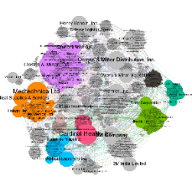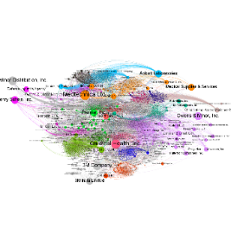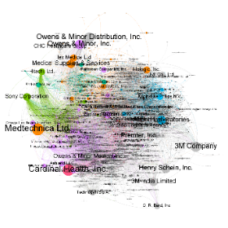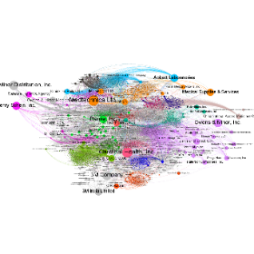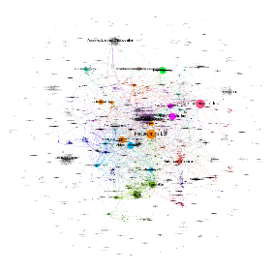

_____1-tier____________2-tier________ _3-tier ______ __4-tier _____ _5-tier_

We identified 1175, 4464, 21775, 32,243 and 157,438 backward dyadic connections across tiers one to five, in respectively. We will develop the same map for 5-tier forward supply chain. In addition to visualizations at different levels, our analysis will include clustering and a variety of centrality analyses. We will identify the most influential elements at the level of firms, clusters of firms, industry, and region. We will conduct various analyses to identify the level of risk and interruptions that certain factors can cause to the global supply chain of medical equipment.

**“Multi-layer Analysis”**

We employ a view of global business that closely follows General System Theory (GST). Consequently, we understand companies and industries as part and parcel to business ecosystems, which exist in complex relationship. Firms operate in multiple layers of ecosystems, where elements of each layer can play various roles across these intertwined layers. The business ecosystem should be investigated through multi-layer analysis of the ecosystem at individual firm, industry, and country-wide levels. Figure 2 displays different levels of analysis that we have developed, which can be employed now for the study of business ecosystems.

Figure 2: Multi-layer analysis of business ecosystems: Layers of business ecosystem sphere

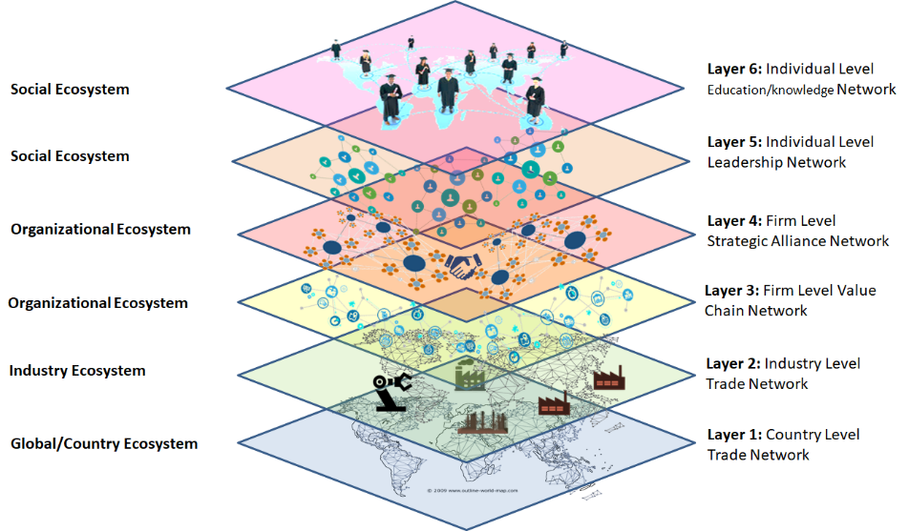

The author of this document has conducted feasibility studies on all layers of the business ecosystem within select industries. While the main goal of Phase A is to analyze the industry-specific global supply chains and its close layers, in Phase B, we can develop and analyze such networks at several levels. Figure 3 displays a single layer visualization of each of the six (6) layers of the business ecosystem.

**“Sample Supply Chain Rupture Simulation”**

On March 27, 2020, the United States’ president “ordered General Motors Co. to … ramp up the production of ventilators”[2]. This was more than two months after the first case of COVID-19 was diagnosed in the United States (state of Washington.) Since time is of the essence in fighting pandemics, policymakers need to have access to tools that can instantaneously provide alternative supply chain paths in case of a disruption using multiple network layers. We will develop a rapid response supply chain interruption simulation tool that will identify alternative supply chain paths in case of disruption in a region, a country, state/province, city, or a collection of firms.

Figure 3: Single-Layer Business Networks Feasibility Study: Limited to one industry[3]

|  |  |  |  |  |  |  |
| --- | --- | --- | --- | --- | --- | --- |
|  | **Layer 1**  Global Trade  https://www.researchgate.net/profile/Kayvan_Miri-Lavassani/publication/326235033/figure/fig1/AS:645481231310848@1530906126514/figure-fig1.png | | **Layer 2**  Global Trade | | **Layer 3**  Pharma Industry Value/Supply Chain | |
| **Layer 4**  Auto Industry Strategic Alliance | | **Layer 5**  Pharma Industry Boards of Directors (BOD) | | **Layer 6**  Pharma Industry BOD education: Knowledge Network of Alma Mater | |  |

The network visualization of our simulation study demonstrates that our algorithm was shown to be capable of correctly identifying auto manufacturing firms as the only alternative to supply medical equipment when supply chains were ruptured in China (Figure 4). Node color in Figure 4 identifies the result of our clustering analysis and the node sizes identify the eigenvector centrality. Each node represents an industry across the 5-tier supply chain of medical equipment as defined in standard industry code. In phase A, we will include sample simulations at different levels of analysis. For Phase B, we propose to develop a pilot interface where the users can select certain firms or countries to be removed from the global supply chain, then our tool will dynamically present alternatives using networking algorithms (c.f. Figure 1).

**Relevance to COVID-19 pandemic**

Syahrir, Suparno and Vananyl (2015) have demonstrated that “healthcare supply chain(s)” are complex, as they require timely procurement of medical needs, such as equipment, medicines, antivirals, and vaccines. Medical equipment along with drugs is a “key input in the healthcare sector” with expected $119.98 billion growth during 2018-2022 (Jha, 2019). One aspect of this complexity is that medical equipment and medicine require raw material inputs, parts, and equipment that must be supplied across multiple tiers of supply chains; and a select few countries have an elevated, out-sized role in maintaining the continuous functioning of this global supply chain. For example, “90 percent of the latex for sterile gloves is produced in Malaysia,” and “a significant portion of surgical hand instruments are manufactured in Pakistan” (MRB, 2016, as cited in NASEM, 2018). In a business environment with high dependencies across borders, the current intertwined global supply chain network is ripe to cause “serious repercussions worldwide.” Generally, such repercussions and disruptions stem from a set of “destabilizing factors --- powerful weather, pandemic, port closures, and political instability --- referred to as the “four P’s (NASEM, 2018).

Figure 4: Medical Equipment Supply Chain Industries: With and Without China[4]

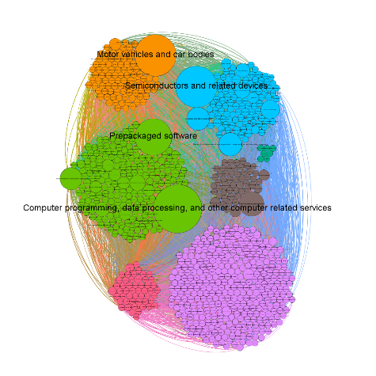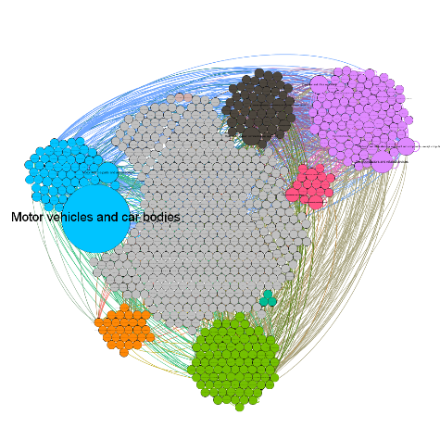

All countries All countries except China

The COVID-19 crisis, in particular, has explicitly exposed policymakers and the general public to the vulnerability of the global supply chains. Researchers had warned that issues such as “90 percent of the latex for sterile gloves [being] produced in Malaysia,” or “a significant portion of surgical hand instruments [being] manufactured in Pakistan” were concerning. (MRB, 2016, as cited in NASEM, 2018) While in the early months, the global supply chain of medical equipment and supplies was identified as a key challenge, in the months following the start of the pandemic, supply of other products and services were interrupted as well. The complexities associated with COVID-19 revealed a special risk of global supply chains--- a risk with high magnitude, short-term, and long-term consequences. (Ivanov, 2020)

To illustrate the impact of these global supply chain challenges, a survey by the National Association of Manufacturers (NAM) conducted in early 2020 of US manufacturers revealed that 53% reported expecting changes in their operations as a result of COVID-19. (NAM report, 2020) Additionally, 78% of respondents reported uncertainty about the financial impact of supply chain disruption on their business. These findings highlight the magnitude of interruptions and challenges that global supply chains and “abnormal” crises pose for businesses and industries.

**Relevance to Intelligence Community mission**

As defined in their missions, IARPA and the Office of the Director of National Intelligence are charged with providing access to “timely, insightful, objective, and relevant intelligence” that bring “intelligence advantage” to the nation for “informed decision making[5]”. The way of the life of citizens can quickly and radically change as a result of interruptions in the global intertwined supply chain. Understanding the risks of the current supply chain structure and designing a resilient supply chain for the future can ensure not only the health and economic condition of individual citizens, but the leadership role that our nation fulfills. COVID-19 exposed not only the fragility of global supply chains but also their importance to national security. Through this project, we will be able to support the intelligence community in their mission to gather, organize, and analyze important information about complex networks associated with global supply chains.

**Summary of products, transferable tech., and deliverables**

**Schedule and milestones**

**Mid-Phase A** (mid second month): Deliver ten-tier mapping of global supply chain of medical equipment at firm-level, industry-level, regional-level, licensing-level, and finance-level.

**Phase A Report** (end of month 3): Deliver newly developed measures of supply chain vulnerabilities and fragmentations, simulations of various scenarios about rupture in the global supply chain, as well as mathematical models to analyze multi-layer networks.

**Phase B Start** (first of month 5): Design the expanded supply chain mapping and analysis based on the need of the intelligence community.

**Mid-Phase B** (mid-month 7): Deliver multi-tier, multi-layer mapping, and report on the progress of developing novel mathematical tools for the network analysis.

**Mid-Phase B** (end of month 9): Deliver progress on the novel mathematical analysis tools. Deliver simulation and analysis interface prototype.

**Final Report** (end of month 12): Deliver comprehensive report, visualizations, network analysis, raw data, processes data, and operational analysis & simulation portal/interface (this could in the form of a public or private webpage).

**Related research**

In widespread natural disasters and “catastrophic epidemic outbreaks” such as COVID-19, there is consensus among researchers that geographically expansive supply chain interruptions are expected. Researchers have identified “disruption(s) in… distribution and transportation” (Syahrir et al., 2015) and “manufacturing limits” (Kumar and Havey, 2013) as primary factors of supply chain interruptions. In their review of literature on health care and disaster supply chain, Syahrir et al. (2015) have demonstrated that most research focuses on exploring supply chain in “normal operating conditions.” Therefore, there is insufficient research and study of supply chains in “abnormal” situations, or what Ivanov (2020) referred to as “special” situations when he called for more COVID-19- related research.

**Project contributors**

Dr. Lavassani will lead the team. He will obtain the data and conduct preliminary clustering and centrality analysis. Dr. Boyd will contribute as a Subcontractor by developing new mathematical approaches to analyzing complex multi-tier and multi-layer networks in a holistic manner. Dr. Mahour Parast, as an expert in supply chain analysis will contribute as a Subcontractor by developing models for supply chain risk assessment and resiliency analysis. Dr. Zackary M. Boyd is an expert in networks analysis and multi-layer network analysis. He will make notable contribution in development of clustering and centrality algorithms to study complex single-layer and multi-layer networks.

**Facilities:** We require computers which are capable of processing large datasets.

**Resource Share:** We have secured access to supply chain data from specific sources, which is mined from financial records. However, if the intelligence community has access to any additional supply chain data that would enhance the project, we would consider incorporating said data into the analysis.

**Statement of Work:**

In Phase A of the project, the focus is on the global supply chain of the medical equipment. The analysis in Phase A will include four components:

1. Mapping and analyzing multi-tier global supply chain networks in the selected sector;
2. Mapping & analyzing select multi-layer global value chain networks corresponding with the global supply chain network;
3. Identifying high-risk firms, clusters of firms, industries, and countries; and
4. Running simulations to identify the alternative procurement routes in case of a rupture in the global supply chain.

We will identify the top countries and firms that can impose the highest interruption to the United States global supply chain of medical equipment. The model will be capable of expanding to a virtually unlimited number of backward and forward tiers. In this phase, we will showcase our multi-layer approach, where the licensing and finance network layers will be also analyzed along with the supply chain network.

In Phase B, we envision developing an interactive portal/interface to address the follow needs: 1) identifying high-risk links across the global supply chain network in select industries, and 2) providing a simulation solution that can simulate various future ruptures.

In this document we provided explicit evidences of feasibility of the work that also displays our unique capability across several industries. We have been developing our capability on this particular domain over the past several years. Deliverables will be in the form of report, visualizations, and analyzed large dataset in Phase A. In phase B we will also deliver a web portal along with new mathematical models for analyzing such complex networks.

1. Colors show the clustering algorithm result, and node sizes indicate eigenvector centrality
2. Wall Street Journal, Trump Orders General Motors to Make Ventilators, March 27, 2020.
3. Except for layers 1 & 2, the other networks are currently limited to one industry. Node sizes represent eigenvector centrality. Node colors represent cluster membership. Layer 3 in Figure 3 is the single-tier value-chain network, which include –but is not limited to– supply chain.
4. The node colors identify clusters in the supply chain network. The node sizes illustrate eigenvector centrality.
5. [www.iarpa.gov](http://www.iarpa.gov/) and [www.dni.gov](http://www.dni.gov/)